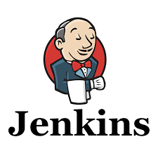

* **GitHub** is the source code management tool, however, it could be BitBucket or Visual Studio Team Services. The branching model and code review process are out of scope at this high level.
* **Jenkins** is chosen as the Build System due to its tight integration with Octopus Deploy and good all-round support for .NET, msbuild and PowerShell. It is an extendable open source continuous integration server.
* **ProGet** is the package management solution which both stores Octopus Packages and proxies public package/image repositories. ProGet helps you package applications and components so you can ensure your software is built only once, and then deployed consistently across environments. This means everyone can be certain that what goes to production is exactly what was built and tested. With high-availability, load-balancing, and multi-site replication, ProGet can centralize your organization’s software applications and components to provide uniform access to developers and servers, no matter where they are in your network.The rationale for not using the built-in TeamCity NuGet store is purely for scalability reasons.
* **SonarQube** provides continuous code quality management and reports are published as part of the TeamCity build outputs.
* **Octopus Deploy** is used as the deployment and release management tool for both infrastructure and code into the target platforms. This product excels for many reasons in the deployment and continuous integration cycle. They have plugins for TeamCity, Jenkins, Azure DevOps and TFS